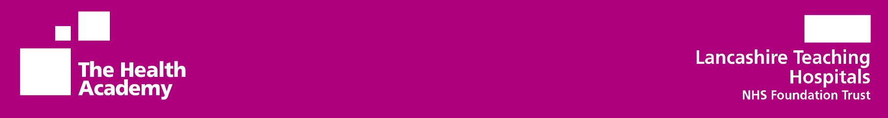 LEARNING ENVIRONMENT

ALLOCATIONS

Adult nursing learners are rotated within all four areas: Medical, Surgical, Specialist and Outward Facing, with a minimum of one allocated learning environment in each area. If a learner would like to review their allocated learning environments, they are to contact their university directly, who will follow our shared guidance should a change to an allocated placement be required.

SURGICAL

Ribblesdale Ward Ward 16

Ward 2A Ward 2B

Gynaecology Ward Ward 2C

Ward 3 Leyland Ward

Ward 4 Surgical Unit CDH

Ward 10 Ward 11

Ward 12 Ward 15, Unit 1

Ward 15, Unit 2 Ward 14

Elective Orthopaedic Rotation

Gynaecology Rotation

MEDICAL

Bleasdale Ward Ward 17

Cuerden Ward Rookwood A Ward

Ward 18 Rookwood B Ward

Ward 21 Brindle Ward

Ward 25 Ward 24

Ward 23 Hazelwood Ward

OUTWARD FACING

INCS Rotation ENT Clinic

Endoscopy Unit RPH Finney House

Endoscopy Unit CDH SMRC Rehab

Rosemere Oncology Barton Ward

Interventional Radiography Rawcliffe Ward

Neuro Infusion Clinic Discharge Lounge

Oncology Outpatients Opthalmic CDH

Acute Frailty Unit Outpatients RPH

Fracture Clinic RPH Outpatients CDH Discharge Lounge

Fracture Clinic CDH (ATC)

Clinical Investigation Unit

Research & Innovation

Renal Home Therapy

Additional learning opportunities are available for all learners on each learning environment. Please click on the QR Code to see your Inter-professional Learning Sessions available to you. (Add QR Code from Learner Board Poster).

Additional resources are available for all learners to access, to support you in evidencing your attitudes, values and skills within your allocated learning environments. (insert QR Code)

SPECIALIST

Surgical Enhanced Care Unit Day Case Unit

Enhanced High Care Sepsis Team

Surgical Assessment Unit Theatres (ALL)

Acute Medical Unit ED RPH

Acute Assessment Unit ED CDH

Critical Care Unit MTW

Cardiac Catheter Lab

Neuro High Care

Coronary Care Unit RPH

Renal Dialysis RPH

Coronary Care Unit CDH

Renal Dialysis CDH

Respiratory Specialist

Medical Assessment Unit CDH

Project Based Placement

Same Day Emergency Care

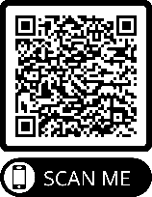

Additional learning opportunities are available for all learners on each learning environment. Please click on the QR Code to see your Inter-professional Learning Sessions available.

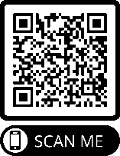

Additional resources are available for all learners to access, to support you in evidencing your attitudes, values and skills within your allocated learning environments.