Lancashire Teaching Hospital NHS Foundation Trust

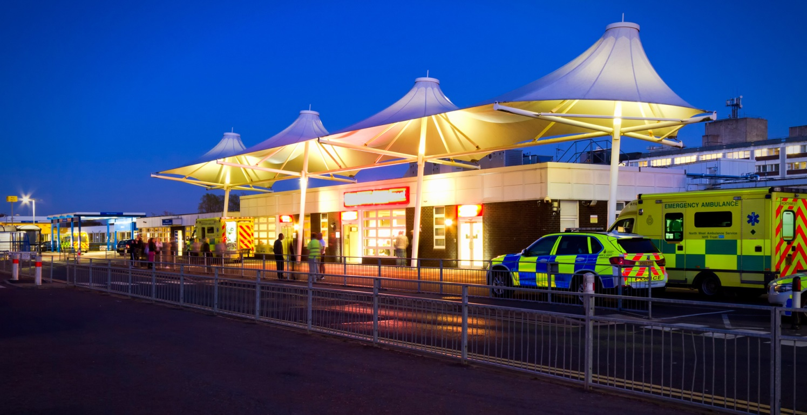

Student Introduction Information and Training Package

Produced by Trish English

Updated Sept 2023

December 2020

Contents 

1. Introduction to the Emergency Department.
2. Meet the team.
3. What you will expect to see on your placement.
4. Typical Medications.
5. Spoke Placements.
6. ED Abbreviations.
7. Housekeeping.



Welcome to the Emergency Department, it can be quite a daunting placement but please do not worry you will be well supported and looked after by our friendly, highly skilled and experienced team.

Prior to your first day you will collect your introduction pack and we will provide you with details of your allocated mentor and your shift pattern. On your first day you will be orientated throughout the department with your mentor or one of our dedicated team.

This is a Major Trauma Centre for the region therefore patients requiring specialised care are transferred to this department via ambulance or helicopter for treatment and emergency / lifesaving care. We also receive patients suffering from a variety or illnesses, conditions and or traumas.

During your placement you will develop new skills and knowledge; including learning opportunities within the department and spoke placements. I hope you enjoy your placement with us.



**Student Management Team: - Michelle Sinclair and Natasha Todd.**

Matron oversees the running of the whole department. She manages departmental budgets, staffing and is a driving force in improving patient safety. Matron provides a focal point for clinical leadership, risk management and governance; as well as ensuring she is an accessible figure for patients, visitors, staff and management, dealing with complaints and ensuring high levels of morale within the team.

Co-ordinators consist of one consultant and one charge nurse / senior sister; and wear a red uniform so that they are easily identifiable within the department. They are responsible for running the whole department providing support and supervision of staff members. The Co-ordinators ensure the smooth running and ‘flow’ throughout the department adhering to targets set by the government and trust.

Co-ordinators are also responsible for ensuring the shifts have the correct staffing numbers and skill mix and often try to cover sickness. They must liaise with matron and site managers within the hospital and often deal with complaints and problems within the department.

ED Doctors are responsible for reviewing nearly all the A&E patients, this includes assessing patients, prescribing medications, diagnosis, planning patient care and referring to specialists.

Advanced Clinical Practitioners (ACP’s) are Registered Nurses who have undergone extra training and academic qualifications to enable them to examine, assess, make diagnoses, treat, prescribe as well as make referrals to specialist for those with undiagnosed problems.

Emergency Nurse Practitioner (ENP’s) are registered nurses who have undergoing extra training in Minor Injuries, booking X-rays and diagnostics and manipulation of limbs.

Senior Sisters/ Sisters and Charge Nurses are responsible for providing support and supervision of junior staff members as well taking charge of each area. One is also allocated each shift as a ‘Helicopter Nurse’ who works closely with the Co-ordinator ensuring the smooth running of the department, as well as supporting all junior staff as well as ensuring mental health and all safeguarding risk assessments have been completed each shift.

Staff Nurses are the backbone of the department and are responsible for all patient care, administration of medications and treatments. Senior Staff Nurses often take charge of a specific area within the department and are responsible for co-ordinating staff, delegation of duties and patient care. Once they have completed the necessary training Staff nurses are able to triage and assess patients upon arrival to the Emergency Department, they also perform transfer of patients to other areas and wards; and will work in all areas of the department under extreme pressures. The nurses working within the department are highly skilled in both Adult and Paediatric care, performing a wide variety of tasks for medical, surgical, orthopaedic, neurological and emergency trauma care.

Healthcare Assistant work alongside our nurses dealing with all aspects of patient care; including the completion of physiological observations, venepuncture and cannulation, ECG’s and assisting with the transfer of patients to x-ray, CT, MRI and other wards.

Housekeeper reports any equipment that needs fixing, will order meals and assist patients and relatives with their nutritional requirements. They also help to keep the department tidy and replenish equipment and supplies.

Clinical Educator coordinates all staff training and development within the department; ensuring that all nursing staff are kept up to date with all new changes and guidelines in clinical practice.

What you will see here...

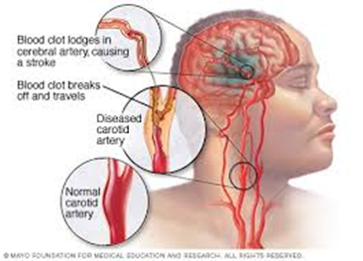

*Stroke – CVA & TIA’s*

A stroke is a serious life-threatening medical condition that happens when the blood supply to part of the brain is cut off. Thrombolization must be carried out within 4hours of onset time. The symptoms of a transient ischaemic attack (TIA), also known as a mini stroke, are the same as a stroke, but tend to only last between a few minutes and a few hours before resolving. A CT scan must be carried out within 4hours of arrival these scans are more urgent if a full CVA and within 4hours from onset of symptoms. Stroke specialist nurses carry out a detailed assessment in the ED. Patient will either be discharged with a TIA clinic appointment or transferred direct to ward 21.

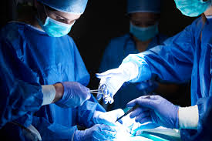

*Surgical - abdominal pain, ischemic limbs or injuries*

You will see patients suffering from appendicitis, bowel obstruction, AAA’s abdominal aortic aneurysm, pancreatitis, renal colic, gallstones, PR bleed, haematuria and / or ischemic limbs. All suspected surgical patients will be put as nil by mouth upon arrival to ED.



*ENT – epistaxis, foreign objects and quinsy*

Patient may attend with spontaneous epistaxis, may have food stuck in their throat which can be life-threatening if left unattended or may have ‘quinsy’ which require intravenous antibiotic therapy or may need aspiration.

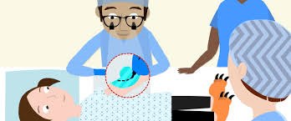

*Burns & Plastics*

Patient’s may attend for the treatment of burns from fires, firework or chemicals; and/ or smoke inhalation from house fires. Other may have severe wounds or tendon injuries that require input or treatment from plastic surgeons.



*Medicine*

Patients may be experiencing chest pain, experiencing a cardiac event, stroke, diabetic Ketoacidosis, exacerbation of Asthma or COPD. Others may have collapsed and or had a loss of consciousness, fallen for reasons unknown, had a severe allergic reaction or suffering from sepsis; and many more.

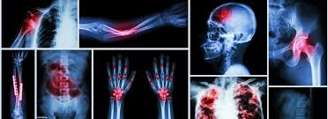

*Orthopaedic*

Patient many have fallen or been in a trauma and suffered a; fractured neck of femur, fractured shaft or femur, dislocation of hips, knees and shoulders. Some of these injures require manipulation under anaesthetic and the application of traction, splints or plaster casts. Other patients may have rib and pelvis fractures and or skull/ facial breaks.

You will see the use of analgesia, traction, manipulation, ‘maxfax’ involvement and/ or surgery. Sometime when ribs are fractured this may cause a condition known as haemothorax or pneumothorax and insertion of a chest drain may be necessary.



*Gynaecological*

This may involve miscarriage, ectopic pregnancies or ladies who may be in labour with an unknown pregnancy and be unaware. These patients may be looked after in resus depending in urgency or may be transferred to EPAU (early pregnancy assessment unit) / Maternity Ward.

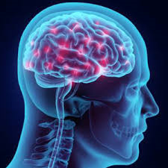

*Neurological*

Patients suffering from subarachnoid haemorrhage, subdural haematomas, extradural haematoma, and / or catastrophic brain injury. Diagnosis is usually by CT or MRI scan, patients may require intubation, anaesthetic support and neurosurgical input.

Patients suffering from subarachnoid haemorrhage, subdural haematomas, extradural haematoma, and / or catastrophic brain injury. Diagnosis is usually by CT or MRI scan, patients may require intubation, anaesthetic support and neurosurgical input. 

*Paediatrics*

Children ranging from newborn to age 16 unless they suffer from complex medical needs then aged 18. May be suffering from bronchiolitis, difficulties in breathing, rashes i.e. meningitis, allergic reactions or simply a viral infection. You will also see injuries, broken bones and sports related injuries, and / or foreign objects where they are not supposed to go; and will have to deal with safeguarding these children.

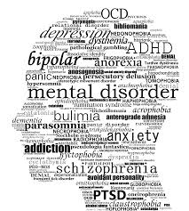

*Mental Health*

You will see suicidal attempts, overdose, DSH (deliberate self-harm), patients suffering from PTSD, psychotic disorders and anxiety / depression. First, we provide any necessary treatment / medication, then the mental health team with review and assess before discharge or admission.

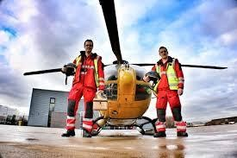

*Major Trauma*

Road Traffic Accidents, high speed / impact injuries, fall from heights, fall full flight of stairs, stabbings, sports injuries, industrial injuries including animal injuries (i.e. kicked by horse or cow); and assaults with or without dangerous objects. ‘Silver Trauma’ is a situation where the mechanism is low, but the patient sustains significantly higher. For Example, an elderly patient may merely ‘fall from standing’, however the injuries may be extremely high due to the age and medical history of the person concerned. All these patients will arrive via ambulance or helicopter, and a major trauma call will be placed to ensure a full team of specialities are on hand to assess each patient.

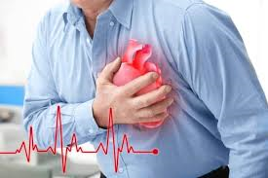

*Cardiac Chest pain - ACS treatment*

Aspirin 300mgs, clopidogrel 300mg, ticagrelor 180mg and 2.5mg fondaparanex.

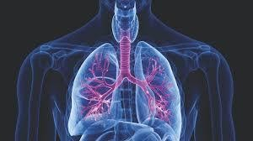

*Exacerbation of COPD*

Salbutamol & Ipotronium nebulisers, prednisolone or hydrocortisone and Aminophylline/ Magnesium infusions.

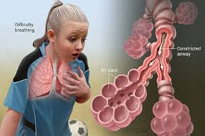

*Exacerbation of asthma*

Salbutamol & Ipotronium nebulisers, prednisolone or hydrocortisone and magnesium infusions. In severe cases a salbutamol infusion will be commenced.



*Trauma*

Tranexamic Acid, blood products including administration of platelets, fresh frozen plasma, and cryoprecipitate, and calcium gluconate – Please note Intravenous fluids are rarely given.

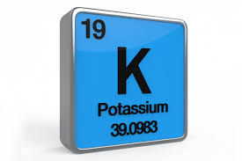

High potassium

Salbutamol nebulisers, calcium gluconate, 10 units of insulin and 250mls 10% dextrose infusion.

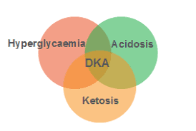

*Diabetic Keto-Acidosis*

Administration of Intravenous Fluids, Potassium replacement and or glucose and insulin is administered to treat this potentially life-threatening condition. This requires close monitoring and regular capillary gases.

Medications

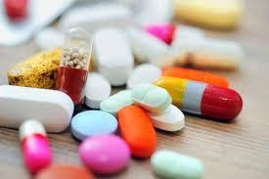

**These are some of the medications used for specific treatment pathways.**

*Analgesia* - Paracetamol, ibuprofen, buscapan, dihydrocodeine, diclofenac, co-codamol, naproxen, morphine and ketamine. More recently we use ‘Penthrox’ an analgesia which is inhaled and very effective when trying to manipulate broken bones.

Stroke / TIA – Aspirin and or Alteplase (thrombolysis treatment).

Pulmonary Embolism - Enoxaparin (clexane) or Alteplase if unstable.

Alcohol Withdrawal – Chlordiazepoxide (Librium) and Pabrinex (VitD).

Paracetamol Overdose – Acetylesteine infusion (otherwise known as ‘Parvolex).

Anti-emetics – Ondansatron 4mg and or Cyclizine 50mg.

Spoke Placements



**2nd Year Students 3rd Year Students**

Ambulance Service Same as year 2 plus

Plaster Room Resus Bleep

Major Trauma Ward Bereavement Team

Intensive Care Unit Organ Donation

Hospital at night team

Paediatrics

Acute Kidney Injury Nurses

Trauma Specialists

Theatre / Anaesthetics

Stroke Nurse

HALS

Mental Health Liaison

**ED – Abbreviations**

**ABR –** Await blood results **HA –** Headache

**ABX –** Abdominal X-ray **HAP –** hospital acquired pneumonia

**AF –** Atrial Fibrillation **HCG –** Pregnancy Test

**AKI –** Acute Kidney Injury **HCP –** Healthcare Professional

**AP –** Abdominal Pain **HI –** Head Injury

**ASP –** Aspiration **HR –** heart rate

**BIBA –** Brought in by Ambulance **HV –** Health Visitor Form

**BIBH –** Brought in by Helicopter **IVA –** Intravenous Access

**CAP –** Community Acquired Pneumonia **IVAB –** Intravenous Antibiotics

**COPD –** Chronic Obstruction Pulmonary disease **IVDU –** Intravenous Drug User

**CP –** Chest pain **IVF –** Intravenous Fluids

**CT –** Computerised Tomography **MI –** Myocardial Infarct

**CXR –** Chest X-ray **MRI -** Magnetic Resonance Imaging

**C?C –** Collapse query cause **MSU –** Midstream Urine Analysis

**D&V –** Diarrhoea and Vomiting **OD –** overdose

**DKA –** Diabetic Ketoacidosis **O2 –** Oxygen

**DSH –** Deliberate Self Harm **RA –** Room Air

**ECG –** Electrocardiogram **SAH –**Subarachnoid Haemorrhage

**EDT –** Social Service Referral **SDH –** Subdural Haematoma

**ETOH –** Excessive Alcohol User **SVT –** Sinus Ventricular Tachycardia

**FOF –** Found on floor **TBS –** To be seen by a doctor

**GTD –** Go to Doc (Urgent Care) **TP –** Transport to be booked

**X2222 –** Do not resuscitate  Dementia Patient  Mental Health Patient



**Working Shift Pattern**

Day shifts 07.00 – 19.30hrs (3 days per week)

Night Shifts 19.00 – 07.30hrs (3 shifts per week)

Extra make up shift required every 8 weeks

NB; you should follow your mentor’s rota as much as possible.

**Uniform Policy**

Please adhere to this – Correct uniform must always be worn, including long hair tied up off the shoulders, no acrylic nails must be worn and no false eyelashes. Please keep visible piercings to a minimum of one.

**Professionalism & Confidentiality**

This must always be maintained.

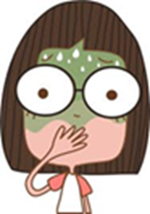

**Sickness and Absence**

If you are ill and are unable to come to your placement, phone into the Emergency Department on Tel; 01772 523442 and ask to speak to the nurse in charge. Please also inform your academic tutor and university.