Aim

Introduction

Methods

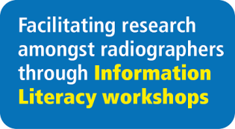
Outcomes

