Core Therapies
(Integrated Occupational therapy and Physiotherapy teams)
Student Handbook 2022

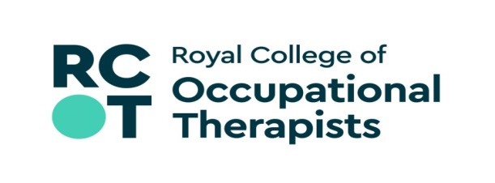

Welcome to

Medicine (Preston)

- Introduction
We hope that you enjoy your time on placement with us at Lancashire Teaching Hospitals NHS Foundation Trust (LTHTR).
We have created this pack as a useful resource to help you to settle in with us. The purpose of this document is to provide you with information to help you on your first visit, as well as serving as a useful reference point until you are familiar with the hospital sites. The document will also help to clarify some questions you may have relating to your clinical work in the department you will be attending.

LTHTR was formed on 1st April 2005. We are one of the largest and highest performing trusts in the country, providing district general hospital services to 370,000 people in Preston and Chorley, and specialist care to 1.5m people across Lancashire and South Cumbria.

We provide care from three facilities:
- Chorley and South Ribble Hospital
- Royal Preston Hospital
- Specialist Mobility and Rehabilitation Centre

We are a regional specialist centre for:
- Adult Allergy & Clinical Immunology
- Cancer (including radiotherapy, drug therapies and cancer surgery)
- Disablement services such as artificial limbs and wheelchairs
- Major Trauma
- Neurosurgery and Neurology (brain surgery and nervous system diseases)
- Renal (kidney diseases)
- Vascular

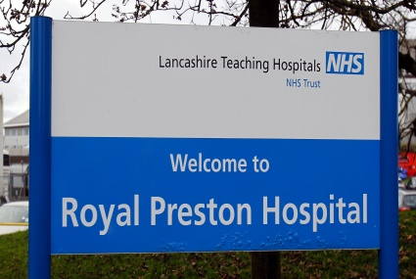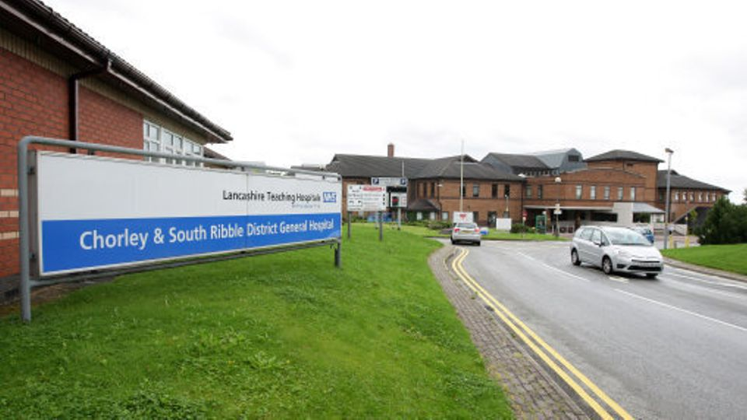

- Our placements

We would like your placement to be a two-way learning process between your Clinical Educator and yourself. We are here to support you in becoming a clinician and offer you the opportunities to develop your clinical skills. We expect that you will have a positive attitude to learning, take responsibility for your own learning outcomes and share this with your Clinical Educator.

The placements we offer are
- Acute medicine
- Acute stroke and stroke rehab
- Surgery and vascular
- Oncology
- Paediatrics
- Critical care
- Neurosciences
- Neurology
- Neuro rehab unit (NRU)
- Lancashire Integrated Frailty team (LIFT)
- Hands team (Outpatient)
- Orthotics
- Burns and plastics
- MSK outpatients
- Specialist mobility and rehabilitation centre
- Women’s health
- Orthopaedics (Trauma and elective)
- Emergency medicine

Role emerging placements
- Health and well being
- SMRC
- Trauma orthopaedic and acute medicine working with patient’s living with cognitive deficits
- Project based placements

- Trust Vision and Values

The Trusts mission is to provide excellent care with compassion.

We have three equally important strategic aims:
- to provide outstanding healthcare to our local communities
- to offer a range of high-quality specialised services to patients in Lancashire and South Cumbria,
- to drive innovation through world-class education, training and research.

We are constantly striving to improve, and working towards becoming an outstanding, high performing organisation.

Our values define who we are and how we behave.

- Caring and Compassionate - We treat everyone with dignity and respect, doing everything we can to show we care.

- Recognising individuality - We respect, value and respond to every person’s individual needs.

- Seeking to involve - We will always involve you in making decisions about your care and treatment, and are always open and honest.

- Team working - We work together as one team, and involve patients, families, and other services, to provide the best care possible.

- Taking personal responsibility - We each take personal responsibility to give the highest standards of care and deliver a service we can always be proud of.

- Your placement is with the Acute Medical Therapy Team
Team structure
Our medical therapy team includes:
3 Band 7 Physiotherapist | 1 Band 7 Occupational Therapist
4 Band 6 Physiotherapist | 5 Band 6 Occupational Therapist
2 Band 5 Physiotherapist | 2 Band 5 Occupational Therapist
4 Integrated Therapy Assistants

We cover the following speciality areas across medicine:
- Respiratory Medicine
- Enhanced Respiratory High Care
- Renal
- Gastroenterology
- Cardiology
- Endocrine
- Elderly Medicine
- We also review medical outlier patients across Avondale ward and Cardiac Catheter Lab
Working hours, facilities & contact number
- Our working hours are 8am – 4pm
- We have male and female locked changing facilities available
- Lockers are limited in the core therapies department however we do have alternative options within the hospital. Please let your educator know if you will require one.
- Our office contact number is 01772 523224 – please contact this number if you require any additional information prior to starting your placement
- Sickness absence should be reported on the above number to your clinical educator at 8am

- Directions
Our medical therapy team is located in the main Physiotherapy Department of Royal Preston Hospital. Please attend the reception area at 8am on your first day.
Royal Preston Hospital
How to find us - by car: From the M6 motorway
Come off at junction 32 off the M6. Turn left off the slip-road onto the A6 Garstang Road, heading towards Preston. At the second major set of traffic lights, turn left into Sharoe Green Lane. The main entrance to Royal Preston Hospital is 200yds on the right.
Alternatively, input PR2 9HT into your SatNav.
Car parking:
Unfortunately, there is no on-site parking available for students or the majority of the staff.
However, you can apply to park at either the Preston Business Centre (PR2 8DY) or Preston Grasshoppers Rugby Football Club Car Park (PR4 0AP).
Preston Business Centre is approximately 1km away and Grasshoppers is 1.5km away. There is a regular free shuttle bus service available from Preston Grasshoppers.
If you wish to park in either carpark, you are required to submit an application before each placement.
Alternatively, you may wish to seek parking in the surrounding residential area. Please note that this would be at your own risk as staff have been known to have their car scratched or vandalised.

To park on site at the Royal Preston Hospital you will either need to park on the public car park – there will be a daily charge which is £3.00 for up to 6 hours and £10.00 for over that. Visitors’ car parks are A, B, G, N, & L.

How to find us - by local transport:
Bus Service:
Preston Bus Ltd operates services from the main Preston Bus Station to the Royal Preston and Sharoe Green Hospitals, via routes through local areas. Services required are numbers 7,19,22,23,123. Preston Bus has recently introduced onto the hospital routes buses adapted for use by disabled people to ensure easy access and exit from public transport. For further information please contact Preston Bus Ltd on 01772 821199 or 01772 253671 or access the following:
The Trainline ; Preston Bus ; Lancashire journey planner ; John Fishwick & Sons
Taxi Service:
Local taxi firms also offer a service to and from the hospital. Free-phones are available at Royal Preston Hospital site to make taxi bookings.
Disabled access:
All entrances to Royal Preston Hospital are accessible by wheelchair, either by being on ground level and/or having low gradient ramps. The hospital also has lifts to all floor levels. Any enquiries should be directed to the Volunteer Information Desk, telephone 01772 716565 ext 3113.

Map of Royal Preston Hospital

There is a shuttle bus service between both sites which students can use. Please request the timetable if you would need to use this to travel between the two hospital sites at the start and end of your day.

- Food, Dining Facilities and other essentials

Royal Preston Hospital
- Our team lunch time is 12:30 – 13:00 – within our therapy department we have a fridge and microwave facilities available.

Other facilities available include;
- Charter’s restaurant on Ground Floor - serves a variety of hot meal options (8am-2pm).
- Café Preston at the main entrance - serves similar food to Charter’s restaurant as well as Costa beverages, sandwiches and cakes (7.30am-7pm)
- WHS and Marks & Spencer mini food hall at main entrance – fresh salads, sandwiches, a range of snacks, toiletries, cards and newspapers
- Mellor’s Catering – Education Centre 1 serves a variety of breakfast and dinner options between 8.30am – 2.00pm.
- There is also a choice of shops across the road from the Main Entrance of the Hospital. However, you are required to be out of uniform to leave the hospital grounds as per the Trust dress code.
- Booths food hall and café / Greggs / Subway
- Costa (a 5 min walk away, opposite the Black Bull Pub on Garstang Rd).

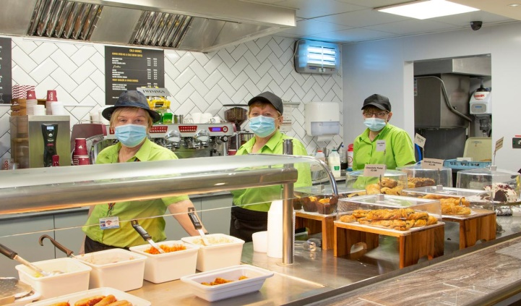

- Learner Support and Wellbeing

The mental wellbeing of our students is of paramount importance. We understand that there are a lot of plates to spin while you are undergoing your training, be it holding down a part-time job, having dependants at home, having assessment deadlines running along clinical practice, financial issues, dealing with matters of conflict or struggling with some aspects of the clinical learning to name a few.

Our experienced Learner Support Team can offer advice, guidance and support to all students, trainee doctors, apprenticeship HCA’s and other learners.

Support with;
- Academic / Health / Personal / Conduct / Placement Issues — to name a few!
- Are you finding work / training difficult due to health, family or personal issues? Please tell us, we can help.
- Have you concerns with regards to your current placement, lack of teaching, supervision or rota issues?
- Concerns with regards to patient wellbeing? It won’t change unless you tell someone.
- Have you been subject to or witnessed bullying, discrimination or harassment during your placement? It needs to stop.
- Are you worried about a trainee or student for whatever reason and not sure who to contact?
- Has a trainee, student or clinical supervisor / teacher / member of staff really impressed you? — Please let us know!

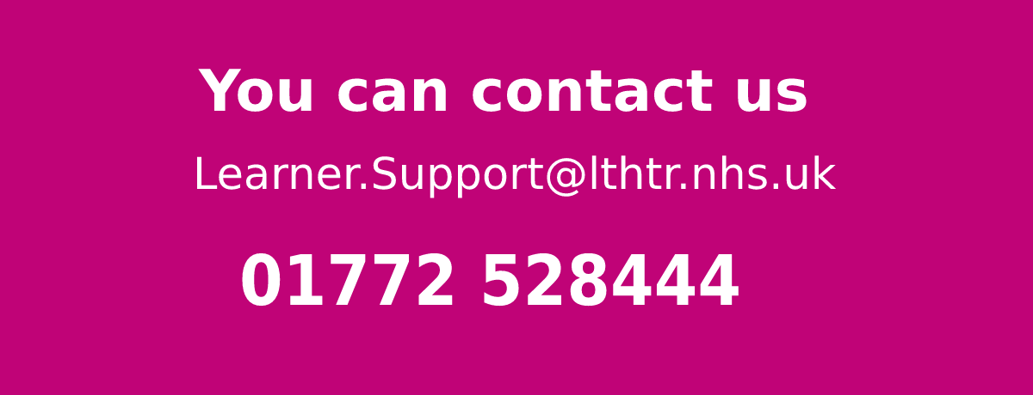

- What to bring on your first day

- Uniform: Please do not attend in your uniform, instead bring one set of uniform with you. All other items in the dress code policy must be adhered to.
- A smallish bag which would fit into a small locker.
- You may wish to bring a packed lunch and a drink on your first day
- Please bring your stethoscope if you have one

- Induction

The Local Induction process will take place throughout the first two weeks of your placement.

This will comprise of:

- Trust and department orientation, including housekeeping information
- Location of emergency equipment
- IT access
- Reading & Acknowledgement of mandatory Trust policies such as Health & safety, Fire Safety, Infection Control, ID, Information Governance, Staff Code of Conduct, Social Networking and Dress Code policies.
- Adult Basic Life Support training if applicable.
- Trust Moving & Handling Training if applicable. You should have completed your university moving and handling prior to commencing placement.
- COVID-related policies & procedure

.
- Your placement

Prior to starting your placement please contact your allocated clinical educator. Here they will be able to advise you which speciality within medicine you will be allocated to. We have provided an overview of the caseload of patients you will be treating to direct your pre-placement reading.

Respiratory Ward Placement
Caseload of patients:
- COPD
- Bronchiectasis
- Asthma
- Pulmonary Fibrosis
- Pleural effusions
- Pneumothorax
- Lung cancer patients
- Critical care step down patients
- See Respiratory Physiotherapy assessment within document
*Please complete some pre-reading surrounding these conditions prior to commencing your placement

Learning opportunities
- Respiratory assessments
- Identification of appropriate management/treatment plans
- Secretion management -ACBT, Aerobika, Flutter, Manual techniques, Cough Assist, IPPB
- Patient education on self-management strategies – exacerbation avoidance, breathlessness Management, energy conservation, anxiety management
- Functional assessments of mobility and transfers- bed, chair and toilet
- Equipment provision to optimise and maintain independence and ease of completing activities of daily living i.e. standard equipment (toilet frame, chair raisers) or more specialist equipment (hoist, wheel chairs)
- Cognitive assessments – i.e. 6-CIT screen, ACE lll and functional assessment
- Routine and complex discharge planning which may in include actioning a safeguarding alert or attend best interest meeting.
- Shadow Home First Discharge service
- Multidisciplinary working i.e. attend/ contribute to MDT morning meetings, joint working and spend time with other professionals/teams
- Develop strong communication skills with patients, relatives, secondary sources and appropriate members of the MDT

Enhanced high care placement

EHCW is a 25-bed high dependency ward, currently divided into 11 beds medical escalation & 14 beds Respiratory High Care

The above divide is due to the new and evolving nature of the ward (only commenced EHCW status in 2020-2021) and the long-term plan remains for the full 25 beds to cater for high dependency patients.

Ward Layout & Staffing

The ward is split into 3-bedded bays, with an additional 4 side rooms.

The ward has a staff room which you are welcome to use on placement, as well as a separate family room for teaching and confidential conversations/meetings.

Nursing ratios with high dependency patients are 1:3, however the medical escalation area may see less nursing staff per patient.

Caseload of patients

Due to the current clinical variation within the ward, you will gain experience with several different clinical conditions. Below are some of the most common conditions/reasons for admission you will be exposed to on EHCW.

- Patients admitted post fall
- Chronic respiratory conditions such as COPD, bronchiectasis, interstitial lung disease (ILD)
- Patients requiring acute NIV
- Patients using long-term home NIV
- Critical Care step-down patients requiring acute respiratory input and extensive rehabilitation
- Patients with tracheostomy and laryngectomy
- COVID positive patients
- Neuromuscular disease such as Motor Neurone Disease (MND) and Multiple Sclerosis (MS)
- Cancer of various origin

You would benefit from completing some pre-reading on the above subjects. Support for learning can be found at https://www.tracheostomy.org.uk and https://www.e-lfh.org.uk

Areas for Shadowing/Further Learning
EHCW has a close knit MDT who work together to achieve the best patient outcomes. Core Therapies as a whole also work very closely between each team. This provides students with many opportunities for shadowing outside their day to day role.
Other areas you may be able to shadow on your placement include:

- Ventilation clinic
- Airways and Bronchiectasis Clinic
- Respiratory Advanced Clinical Practitioner (ACP)
- Nursing staff (working with patients on NIV/tracheostomy patients)
- Dietetics
- Discharge Facilitator
- Critical Care
- Neurosurgery

Please speak to your educator at the earliest opportunity to try to organise shadowing/experience in any areas of interest.

Renal
Caseload of patients:
- Renal failure
- Chronic Kidney disease
- Haemodialysis
- Peritoneal dialysis
- Metabolic Acidosis
- Amputee’s
- Critical care step down patients

Learning opportunities:
- Shadow Home First Discharge service
- Functional assessment
- Patient Education
- Functional assessments of mobility and transfers- bed, chair and toilet
- Equipment provision to optimise and maintain independence and ease of completing activities of daily living i.e. standard equipment (toilet frame, chair raisers) or more specialist equipment (hoist, wheel chairs)
- Cognitive assessments – i.e. 6-CIT screen, ACE lll and functional assessment
- Routine and complex discharge planning which may in include actioning a safeguarding alert or attend best interest meeting.
- Shadow Home First Discharge service
- Multidisciplinary working i.e. attend/ contribute to MDT morning meetings, joint working and spend time with other professionals/teams
- Develop strong communication skills with patients, relatives, secondary sources and appropriate members of the MDT

Cardiology
Caseload of patients:
- Myocardial Infarcts
- Heart failure
- Pulmonary Oedema
- Post pacemaker
- Angina
- Postural Hypotension
- Acute Kidney Injury
- Critical care step down patients
Learning opportunities:
- Shadow Cardiac Rehab
- Shadow Cardiac Nurses
- Post op requirements following interventions
- Functional assessments of mobility and transfers- bed, chair and toilet
- Equipment provision to optimise and maintain independence and ease of completing activities of daily living i.e. standard equipment (toilet frame, chair raisers) or more specialist equipment (hoist, wheel chairs)
- Cognitive assessments – i.e. 6-CIT screen, ACE lll and functional assessment
- Routine and complex discharge planning which may in include actioning a safeguarding alert or attend best interest meeting.
- Shadow Home First Discharge service
- Multidisciplinary working i.e. attend/ contribute to MDT morning meetings, joint working and spend time with other professionals/teams
- Develop strong communication skills with patients, relatives, secondary sources and appropriate members of the MDT
*Please complete some pre-reading surrounding these conditions prior to commencing your placement

Gastroenterology
Caseload of patients:
- Liver cirrhosis
- Hepatic Encephalitis
- Confusion / Delirium
- Ascites
- Alcohol excess
- Crohn’s
- Irritable Bowel Syndrome (IBS)
- Constipation
- Acute/Chronic Pancreatitis
- Gall bladder disease
- Eating disorders
- Critical care step down patients
- Cancer: Colorectal, gall bladder, pancreatic, Oesophageal

Learning opportunities:
- Opportunity to shadow Hospital Alcohol Liaison Team
- Functional assessment
- Cognitive screen and assessments
- Patient Education
- Functional assessments of mobility and transfers- bed, chair and toilet
- Equipment provision to optimise and maintain independence and ease of completing activities of daily living i.e. standard equipment (toilet frame, chair raisers) or more specialist equipment (hoist, wheel chairs)
- Cognitive assessments – i.e. 6-CIT screen, ACE lll and functional assessment
- Routine and complex discharge planning which may in include actioning a safeguarding alert or attend best interest meeting.
- Shadow Home First Discharge service
- Multidisciplinary working i.e. attend/ contribute to MDT morning meetings, joint working and spend time with other professionals/teams
- Develop strong communication skills with patients, relatives, secondary sources and appropriate members of the MDT

Endocrine
Caseload of patients:
- Diabetes
- Adrenal insufficiency
- Addison’s disease
- Cushing syndrome
- Hyperthyroidism
- Hypothyroidism
- Hashimoto Thyroiditis
- Grave disease
- Critical care step down patients

Learning opportunities:
- Shadow Home First Discharge service
- Patient Education
- Functional assessments of mobility and transfers- bed, chair and toilet
- Equipment provision to optimise and maintain independence and ease of completing activities of daily living i.e. standard equipment (toilet frame, chair raisers) or more specialist equipment (hoist, wheel chairs)
- Cognitive assessments – i.e. 6-CIT screen, ACE lll and functional assessment
- Routine and complex discharge planning which may in include actioning a safeguarding alert or attend best interest meeting.
- Shadow Home First Discharge service
- Multidisciplinary working i.e. attend/ contribute to MDT morning meetings, joint working and spend time with other professionals/teams
- Develop strong communication skills with patients, relatives, secondary sources and appropriate members of the MDT

Elderly Medicine
Caseload of patients:
- Falls (with/without sustaining injuries eg. Fractures, head injuries)
- New confusion
- Delirium
- Dementia
- Long standing neurological conditions eg. Parkinson’s/MS (multiple sclerosis
- Postural Hypotension
- Functional decline
- Critical Care Step downs
Learning opportunities:
- Shadow falls team
- Shadow Frailty Team
- Shadow Home First Discharge service
- Single Handed Care Agenda
- Patient Education and/or Carer Education
- Functional assessments of mobility and transfers- bed, chair and toilet
- Equipment provision to optimise and maintain independence and ease of completing activities of daily living i.e. standard equipment (toilet frame, chair raisers) or more specialist equipment (hoist, wheel chairs)
- Cognitive assessments – i.e. 6-CIT screen, ACE lll and functional assessment
- Routine and complex discharge planning which may in include actioning a safeguarding alert or attend best interest meeting.
- Shadow Home First Discharge service
- Multidisciplinary working i.e. attend/ contribute to MDT morning meetings, joint working and spend time with other professionals/teams
- Develop strong communication skills with patients, relatives, secondary sources and appropriate members of the MDT

- Documentation
Within the trust we follow the SOAP format for all therapy documentation. Below we have attached a prompt sheet for you to familiarise yourself with.
You can also print this page as a visual prompt to assist your note writing. We will provide you with a printed crib sheet during your placement if you would find this beneficial for your learning.
SOAP Notes
Heading
Profession Specific or Joint assessment – please include all members of staff present for treatment session. Eg:
Joint session – Physiotherapy & Occupational Therapy – J.Bloggs (StPT), T.Smith (B6PT) & B.Thompson (B5OT).
S: Subjective Assessment
- Consent – Verbal, non-verbal or in patients best interests
- Include any information handed over by members of staff – Eg. Fall overnight, is awaiting an xray
- Include anything else the patient reports if clinically relevant
*When completing an initial assessment with a patient is it recommended to review and include the following information:
HPC: History of presenting condition
- What has led to this hospital admission
- What are they currently being treated for
- What is their current management
PMH: Past medical history
- Include all past medical history – this is usually available on the doctors clerking in entry in A&E or in the daily ward round notes
SH: Social History
- Where does the patient live?
- Who do they live with?
- What kind of property is it? - Does it have steps to access, do they need to complete stairs, where are their bathrooms located?
- Do they have any equipment? – Grab rails, commode, raised toilet seat, bathing equipment (shower over bath or walk in shower, bath seat/rails), bed lever, elevated bed rest.
- How do they usually transfer: in/out of bed, on/off the toilet, out of a chair
- How do they usually mobilise? – Stick, frame, returner, hoist, bedbound?
- Can they complete their own personal care?
- Can they complete their own activities of daily living?
- Do they have any support from family or a formal care package?
- How is their cognition?
- Have they been coping prior to admission? Have family raised any concerns?

O: Objective assessment
- Please see additional section for respiratory assessment
- Have they had their vital signs checked recently?
- Are they stable for therapy input today?
- How do they appear in bed?
- Check active range of movement of limbs and muscle power – document any weakness deficits
- If unable to complete active range of movement review their passive range
- Was the patient confused during the assessment?
Rx: Treatment
- What treatment have you completed during the session? Please note this is not an extensive list
This could include the following:
- Personal care assessment
- Cognitive assessment
- Orientation
- Bed exercises
- Bed transfer
- Sit to stand
- Chair transfer
- Mobility
Be sure to include required amount of staff to complete functional sections. For example: sit to stand from bed with minimal assistance of 2.

A: Analysis
- Identify the patient’s problem list – eg: muscle weakness, variable sitting balance, reduced exercise tolerance, fear of falling ect.
- Clinically reason why you think this is their presentation
- Analyse any response to treatment
- How did they tolerate the session? How did they engage?
- Was the patient confused and did this limit engagement or safety?
P: Plan
- SMART goals for patient
- Specific therapy plan for next session – aim to progress mobility from 3m with wheeled zimmer frame to functional distance required for home
- Recommendations for ward staff – Patient can sit out with assistance of 2 for all meals / can use the bedside commode for toileting
* It is your responsibility to ensure all documentation is countersigned

Respiratory Physiotherapy Assessment
What information do I need to know?
Information gathering is crucial before completing an assessment of your patient. This can be done over the phone from the referrer or from the patient notes.
History of Presenting Condition (HPC):
- What has the patient come to hospital with?
- Overview from admission to Physiotherapy referral
- Onset of respiratory symptoms
- What treatment have they had / are currently having?
Past Medical history (PMH):
- Do they have any long term respiratory conditions?
- What is their usual volume and colour of sputum?
- Are they on home NIV/CPAP?
- Are they set up on any physio adjuncts ? Eg. Cough assist, LVR bag, Aerobika
- Are they known to any outpatient/Community respiratory services? Eg. Vent team, MND, Community COPD
- Do they have a cardiac history?
- Any other medical conditions?

Drug History:
Pre admission medication:
- Do they have inhalers?
- Are they on home nebulisers?
- Are they on mucolytics?
- Any Analgesia (oromorph/diazepam)?
- Diuretics?
Review this admissions medications:
- Inhaler- check they have the correct technique
- Are they on Saline Nebulisers?
- What bronchodilators are they on ? (Salbutamol, Ipratropium, aminophylline, Magnesium)
- Any analgesia?
- Mucolytics?
- Cardiac medications?
- Anticoagulants ?

Social History:
- Property type and who they live with
- Exercise tolerance/Mobility
- Ability to complete ADLS
- Smoker/Ex smoker
- Are they on long term oxygen therapy? (LTOT)
*It is also useful at this point to know your patients ceiling of care and escalation plan

Patient assessment
Completing an A – E Assessment will give you a comprehensive overview of the patient to allow you to identify their main presenting problem and to clinically reason an appropriate treatment.
A – Airway
B – Breathing
C – Circulation
D – Disability
E – Exposure / Environment
- – Airway
Is the Patient maintaining their own airway
- Is the airway patent?
- Comfortable breathing with no upper airway added sounds, indicates a patent upper airway
- Non patent airways can present with stridor
- Is it occluded?
- Please optimise the patients head position into neutral wherever appropriate. Rolled towels can be helpful to aid positioning
- Inserting an Nasal or Oral airway can be beneficial to maintain the patients airway if they are appropriate to insert.
- If they are not maintaining their own airway they need escalating to the critical care team and resus team as they are at risk of a peri arrest
- Do they have a Tracheostomy ?
- What model is it? (eg Tracho twist, Trachoe Twist plus)
- What size is it? This is stated on the back plate of the tracheostomy and will determine your suction size choice.
- Is it cuffed or uncuffed? Is the cuff inflated?
- Check what inner tube is in situ – fenestrated or unfenestrated?

- Breathing
- What respiratory support is the patient on?
- Simple Facemask - How many litres are they on?
- Nasal cannula – How many litres are they on? Are they a nose or mouth breather?
- Venturi Mask – What % and flow are they on?
- HFNCO – What litres and flow are they on?
- CPAP/NIV – What pressures and oxygen support are they on

- Check the recent chest xray & compare to any previous films if available
Look:
- What is the patients respiratory rate?
- What is their Work of breathing?
- What is their Pattern of breathing?
- Are they using any accessory muscles?
- Any signs of fatigue or apnoea?
Listen:
- Auscultate!
- Do they have air entry throughout? Which lobes have reduced air entry?
- Do they have any added sounds? Which lobes are the added sounds present?
Description | Sounds | Potential Causes
Normal Breath Sounds | Soft and low pitched, should be heard throughout the lung fields | Normal Breathing – air passing through large & small airways
Coarse Crackles | Bubbling | Air passing through secretions
Fine Crackles | Crumpling of tissue paper | Pulmonary Oedema, Pulmonary Fibrosis
Polyphonic Wheeze | High pitched & musical | Narrowing of the airways – eg. COPD or Asthma
Monophonic wheeze | Single tone wheeze | Large airway narrowing – eg. secretions, tumour or foreign body
Pleural rub | Friction of pleural rubbing together. ‘Walking on snow’ | Pleural effusion or pneumonia
Absent sounds | Nil audible | Collapse, consolidation, pneumothorax, lobectomy
Stridor | Upper respiratory tract wheeze/snore | Inability to maintain upper airway

Feel:
- Assess the patient’s chest expansion
– Are they getting equal expansion, does Left = Right
- Are they gaining basal expansion?
- Are there any palpable secretions?
- Where can you feel the secretions?
- Any surgical emphysema present?

(C) Circulation
- Heart rate
- If the patient is bradycardic or tachycardic be mindful of their stability for treatment
- Blood pressure
- Be mindful of low blood pressure if you are completing treatments that will change intrathoracic pressure as this will increase blood flow resistance and drop blood pressure further
- In hypertension patients be mindful treatment choices may aggravate patients and elevate this further
- Capillary refill
- A time of > 2 seconds can indicate hypoperfusion
- Overall are they haemodynamically stable enough to treat?

(D) Disability
- Alertness
- GCS or AVPU
- What is the cause for the drop in consciousness? If this is new then please escalate to the medical team for urgent review
- Fluid balance
- Is there a cardiac element of their symptoms? Are they fluid overloaded? Are the dehydrated?
- Bloods
  - Blood results can give you an indication of inflammatory responses with white cell count (WCC) and CRP results
  - HB – this is the haemoglobin in the patient’s blood, this is important for oxygen transport to your organs. A low count can result in symptoms of shortness of breath
  - Platelets – Are they appropriate for airway insertion or manual techniques
- Blood sugars
– low blood sugars may result in drowsiness and confusion
- Temp
- Can indicate an infective cause of patient symptoms
(E) Exposure / Environment
- Attachments – chest drains, IV’s, catheter, slings/braces
- Position – in bed or chair

- Reflections

Reflection template
Reflective templates for both the Gibbs’ and Kolb reflective model cycles have been included for your use, but you may use others if you already have a preferred model. Please share regular reflections with your educator to demonstrate consolidation of your learning.
Gibbs’ 1998 Reflective Model

Description of the experience
Feelings and thoughts about the experience
Evaluation of the experience, both good and bad
Analysis to make sense of the situation
Conclusion about what you learned and what you could have done differently
Action plan for how you would deal with similar situations in the future, or general changes you might find appropriate.
Gibbs, G. (1988) Learning by Doing: A guide to teaching and learning methods. Further Education Unit. Oxford Polytechnic: Oxford.

Kolb’s 1984 Reflective Model
Concrete Experience
(Doing/ having an experience)

Reflective Observation
(reviewing/ reflecting on the experience)

Abstract Conceptualisation
(Concluding/ learning from the experience)

Active Experimentation
(planning/ trying out what you have learnt)

Kolb, D.A. (1984) Experiential Learning: Experience as the Source of Learning and Development. New Jersey: Prentice-Hall.

SWOT Analysis
Please complete this in your first week and provide to your clinical educator.
Weaknesses
Strengths

Threats
Opportunities

