Put the name of department or division here

HOSPITAL ALCOHOL LIAISON SERVICE (HALS)
STUDENT PACK
&
WORKBOOK

Name: Placement date:

Contents:
- The Trust Values
- The Service
- Housekeeping
- Expectations
- Two week placement diary
- Units
- Screening
- Audit-C Tool
- Alcohol and the NHS
- Alcohol Services
- The effects of Alcohol on the body
- Alcohol dependence
- Alcohol Withdrawal
- Chlordiazepoxide
- Pabrinex
- Refeeding Syndrome
- Alcohol Related Liver Disease
- Wernicke-Korsakoff Syndrome
- Hepatic Encephalopathy
- Liver Function Tests
- Stigma
- Talking to patients
- Health Promotion
- Dual Diagnosis
- The Toxic trio
- Safeguarding
- Communication
- Holistic care
- Brief Interventions
- FRAMES
- The Stages of Change
- The Cycle of Grief
- References

- Trust Values

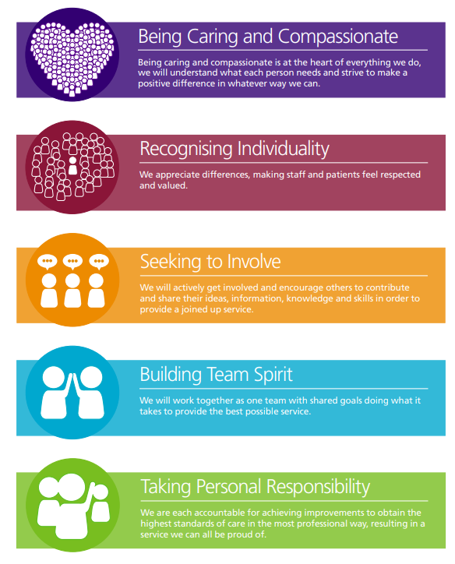

- The Hospital Alcohol Liaison Service (HALS)

The team was set up in April 2013 to tackle the increase in patients being admitted to our hospital with alcohol related issues.

The aim of the service is to reduce the rate of increase in alcohol related hospital emergency admissions, reduce the length of stay in hospital for alcohol related issues and improve access and engagement with community specialist alcohol services. The team assess and provide brief nursing interventions, including personalised feedback and motivational interviewing, to dependent and other high-risk drinkers attending RPH and CDH Emergency Departments or admitted to hospital.

The service is provided over a seven day period from 08.30-16.30 throughout the year at both RPH and CDH.

As part of any patients’ hospital admission or outpatient appointment, they can now expect to be asked questions about their alcohol intake. This is part of the clerical process and is not to cause any offence. This screening tool can help staff identify patients whose alcohol use may be putting their health at risk, and who may benefit from a referral to the HALS service.

Alcohol related health problems and admissions have been increasing for some time. Research shows that earlier identification and interventions can help people understand more about the long term effects of increased alcohol intake, therefore improving future health outcomes.

- Housekeeping

- 7 day 5 Mon-Sun
08:30-16:30
Covering both RPH and CDH

- Contact details
Office number: 01772 528428
Bleep : 3266
Email: Lth-tr.alcoholliaison@nhs.net
- Trust policies and guidelines can be found in the student folder in the HALS office. It includes Infection Prevention and Control, Fire Safety, Resuscitation etc.

- Fire assembly point is on the grass opposite Day Treatment centre entrance. The nearest fire extinguisher is in the access corridor above the stairs, a foam extinguisher.

- HALS has been granted covid safe status for placements, please inform your mentor if you need further risk assessment for any of the following: disability, BAME, pregnancy etc.

- Expectations of our students

- Generic expectations (in accordance with NMC: Standards)
  - Be accountable, professional, punctual, presentable,etc.

- Specific expectations to HALS
By the end of your placement with HALS we would expect you to be working towards/or have achieved:

- Be able to take a basic alcohol history

- Have a good understanding of the Audit-c screening tool and be able to use it.

- Be able to deliver brief advice to encourage a reduction in alcohol use and reduce the risk of alcohol harm.

- Identify patients at risk of alcohol withdrawal

- Have a good understanding of the risk assessment used to monitor alcohol withdrawal symptoms (CIWA-Ar) and know how to use it safely.

- Know when and how to escalate concerns

- Two week placement diary
Week 1
 | Mon | Tues | Weds | Thurs | Fri
AM (new assessments and reviews) | On the wards/ ED | On the wards/ ED | On the wards/ED | On the wards/ED | On the wards/ED
PM (self-directed study) | E-learning  &  NICE and Trust guidelines | Units, screening, effects on body | Dependence, withdrawal, | ARLD, HE, Wernickes, LFTs | RPH Liver Clinic

Week 2
 | Mon | Tues | Weds | Thurs | Fri
AM (new assessments and reviews) | On the wards/ ED | On the wards/ ED | On the wards/ ED | On the wards/ ED | On the wards/ ED
PM (self-directed study) | Safe guarding, dual diagnosis, and Toxic Trio | Fibroscan clinic | Interventions: 5 stages of grief, cycle of change, FRAMES | Community services | Sign off

7. Units
What is a unit of alcohol?

How do you work out units?
One unit equals 10mL or 8g of pure alcohol. You can work out how much alcohol is in your drink, based on its strength and size.

Strength (alcohol by volume or ABV) x volume (millilitres) = total number of units in that drink 1,000

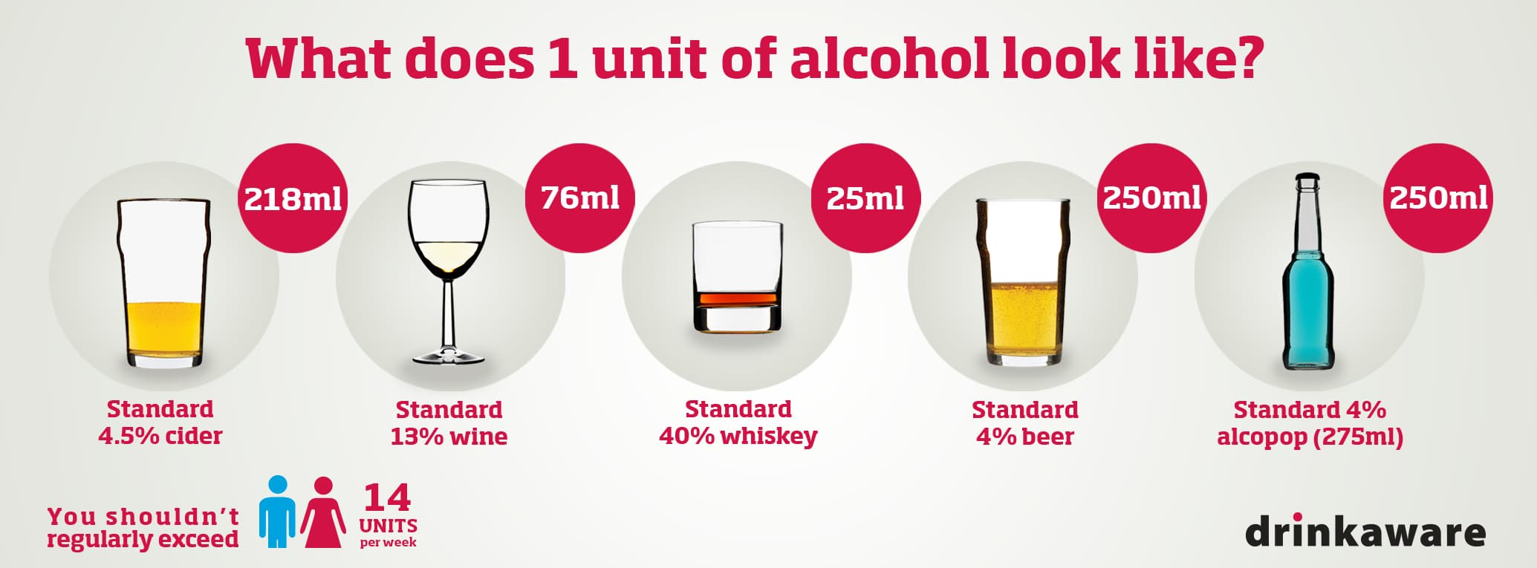

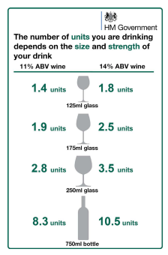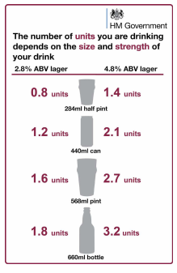
Government recommendations
What is the maximum amount of units the UK’s Chief Medical Officers recommended across the week?

Is this the same for men and women?

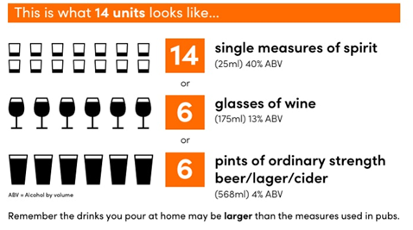
How much is too much?

Low risk drinking guidelines:
- It is best to spread your drinking over 3 days or more. If you have 1 or 2 heavy drinking sessions per week you increase your risk of long term illness or injury.
- If you wish to cut down the amount you drink, a good way to achieve this is to have several alcohol free days per week.

Why is asking patient about alcohol consumption important?
.

8. Screening
The Government’s vision is to help people live well for longer. It cites reduction in alcohol consumption as one of the keys to healthy living. Practitioners should feel assured that acting on opportunities to assess their patients’ drinking is a valuable use of consultation time.
NHS health checks and new patient registration are two opportunities for alcohol screening, but opportunities arise during many types of consultation, ask about alcohol at every relevant opportunity.
Discuss these 5 key opportunities to raise alcohol with your patients:
- Weight

- Raised blood pressure

- Sleep disturbance

- Low mood and depression

- Raised liver enzymes

9. Alcohol use disorders identification test for consumption (AUDIT C)
This test quickly identifies alcohol harm in patients. At LTHTR the AUDIT-C tool is used to complete a patient’s alcohol assessment on admission. Healthcare professionals complete 3 questions on consumption.
(https://www.gov.uk/government/publications/alcohol-use-screening-tests)
They should give feedback to the patient their on AUDIT-C score.
If the score is:
- 4 or below, give positive feedback and encourage your patient to keep their drinking at low-risk levels
- 5 to 10, give brief advice to encourage a reduction in alcohol use and reduce the risk of alcohol harm
- 11 or above, consider referral to specialist alcohol harm assessment

Types of alcohol use
Give more detail about the following:
- Low risk

- Hazardous risk

- Harmful risk

- Dependent risk

10. Alcohol and the NHS
In 2019 the NHS launched its NHS Long Term Plan. As part of new NHS prevention measures, people who are alcohol dependent are helped by Alcohol Care Teams. Alcohol Care Teams were rolled out in hospitals with the highest number of alcohol-related admissions and support patients and their families who have issues with alcohol misuse.
They were delivered in the 25% worst affected parts of the country and aimed to prevent 50,000 admissions and almost 250,000 bed days over five years.
Alcohol-related admissions to hospital have grown by 17% over the last decade – in 2016/17 there were 337,000 estimated admissions – 2.1% of the total.
Alcohol-related harm is estimated to cost the NHS in England £3.5 billion every year.

What impact might alcohol have on the following?
- Hospital admissions

- Outpatients

- ED

- GP practices

- Ambulance service

11. Alcohol Services
Below is a non-exhaustive list of use contacts for alcohol problems. See what you can find out about each and be specific to our local area.
- Alcoholics Anonymous (AA)
- Drinkline
- We Are With You
- Adfam
- National Association for Children of Alcoholics (Nacoa)
- SMART recovery
- CGL Inspire
- Armed Forces Covenant

Family and friends
It can be very difficult to know how to help people who use alcohol, especially if they are addicted.
In reality there may be a limit to the amount of support you can give someone with severe problems, or how much you can get them to change.
However these tips may be useful
- Encourage them to seek help
- Support them to use services
- Encourage them to continue with treatment
- Spend positive time with them
- Look after yourself

Have a look at the following, what did you learn?
- Al-Anon Family Groups

12. The effects of alcohol on the body
Alcohol affects the body in a number of ways and can impact on your short and long term health.
The more you drink the greater the chance of developing alcohol related problems.
Which of these are short term and which are long term?
(put them in the correct box)
Lowered inhibitions Stenosis Stroke
Trouble concentrating Passing out Raised Blood pressure
Loss of co-ordination High blood pressure Alcoholic hepatitis
Loss of judgement Dulled perceptions Raised body temp
Loss of attention span Trouble learning Liver fibrosis
Memory loss Increased cancer risk Cardiomyopathy
Mood swings Irregular heart beat Vomiting
Diminished grey matter in the brain Skin flushing

Short term

Long term

Short term effects of alcohol on the body
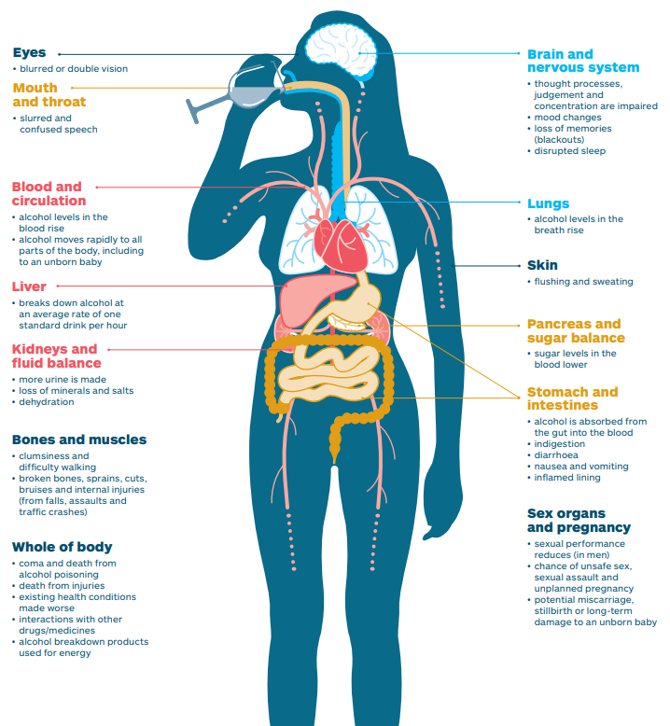

Long term effects of alcohol on the body

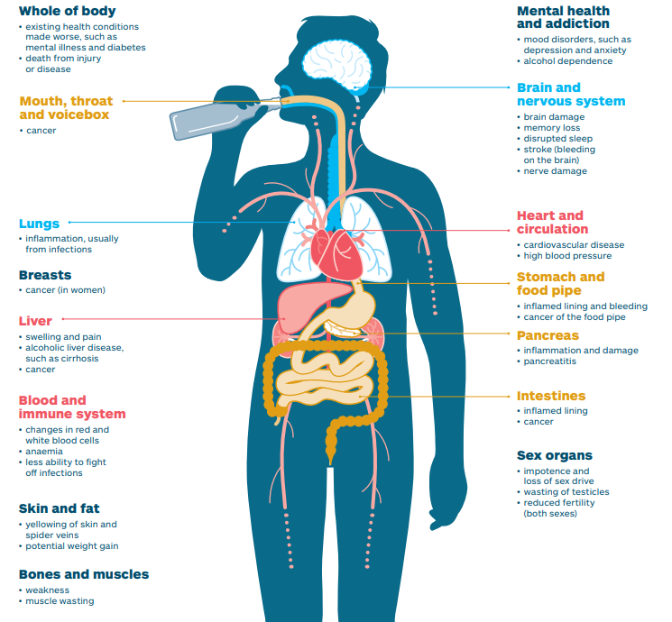

What do you think the effects of alcohol are on a person’s mental health?

Give more detail about the following?
- Alcohol and anxiety

- Alcohol and depression

- Alcohol and suicide, self-harm and psychosis

.

If there are concerns about a person’s mental health they can get help from a mental health charity or organisation like Minds Matter.
What can you find out about Minds Matter? Find out who can refer and how

What are the social and economically effects of alcohol on the following:
- Employment

- Family

- Poverty

- Violence

- Economic and social costs

- Forensic implications? (probation, domestic violence etc.)

13. Alcohol dependence
How would you describe alcohol dependence?

Alcohol dependence is a clinical term to describe a cluster of behavioural, cognitive and physiological factors:
- A strong desire/sense of compulsion to drink alcohol
- Difficulties controlling its use
- Tolerance to its effects
- Persistent in drinking despite its harmful effects
- Giving alcohol a higher priority than other activities/obligations
According to the ICD 10, a definite diagnosis is made when three or more have been present at the same time during the previous year.
How does alcohol dependence happen?

Dependence develops when the brain adapts to the presence of alcohol and needs it to function normally.
No one sets out to become an alcoholic, but regular, heavy drinking can result in alcohol dependence and addiction.
When someone drinks, alcohol enters the brain and disrupts the delicate balance of chemicals called neurotransmitters that keep the body functioning normally. This disruption leads to the numerous behavioural changes and physical signs associated with intoxication
Fortunately, these effects are temporary and wear off after the body breaks down the alcohol. But when exposure to alcohol is ongoing, the brain seeks to compensate for these effects, and a complex cascade of long-term chemical changes begin to occur. As these changes occur, people require increasingly larger amounts of alcohol to become intoxicated. As a result, their drinking will often escalate.
At the same time, the drinker will likely begin to experience intense cravings for alcohol and distressing physical withdrawal symptoms. To avoid these uncomfortable symptoms, a person may begin drinking frequently or around-the-clock.
Chronic, heavy alcohol use also wreaks havoc on the brain’s reward system, which can alter the way the brain perceives pleasure and limit a person’s ability to control their behaviour. Over time, these changes, along with the effects of tolerance and withdrawal, can create a vicious cycle of dependence that keeps the person hooked on alcohol.

Symptoms of alcohol dependence
- Worrying where the next drink is coming from and planning social, family and work events around alcohol.
- Finding a compulsive need to drink and difficult to stop once started.
- Waking up and drinking or finding the need for a drink in the morning.
- Suffering from withdrawal symptoms such as sweating, shaking and nausea, which stop once alcohol is consumed.

Try and find the following alcohol related words:
Cirrhosis Compulsion Control
Dual diagnosis Malnutrition Mental health
Persistence Prioritisation Safeguarding
Stigma Tolerance Units
Withdrawals Worrying
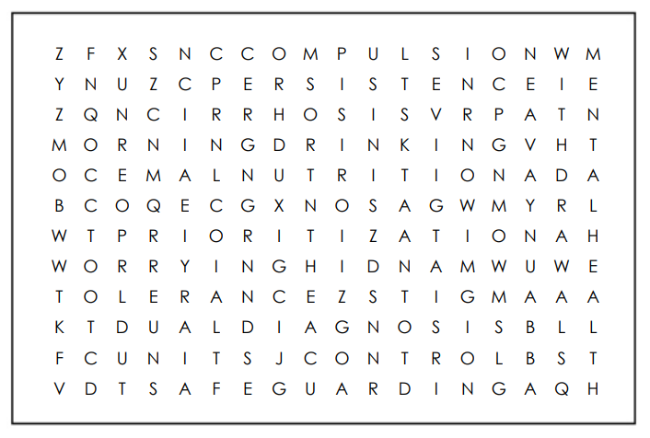

Treatment for alcohol dependence
There are several medications that are recommended by NICE:
- Acamprostate
- Disulfiram
- Naltrexone
- Nalmefene
How do Acamprostate and Disulfiram differ in their approaches?

Therapies for alcohol dependence
Tell us more about the different types of therapies and give examples:
- Self-help groups:

- 12 Step Facilitation Therapy:

- Cognitive-Behavioural Therapy:

- Family Therapy:

14. Alcohol Withdrawal
Withdrawal symptoms are potentially dangerous and should be treated as a serious warning sign of alcohol dependence.
Find out what these symptoms are, what causes them and how we manage them. Make reference to the following:
- NICE Alcohol-use disorders: diagnosis, assessment and management of harmful drinking (high-risk drinking) and alcohol dependence
Clinical guideline [CG115]
- LTHTR Alcohol Use-Disorders v1.2 Guideline
- Complete the Trust’s mandatory e-learning: The Management of Alcohol Withdrawal, Delivering very brief advice for Alcohol and Smoking.

Time line of withdrawal
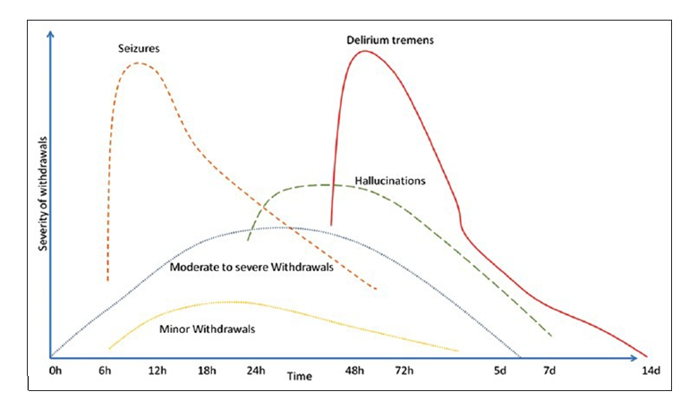

Monitoring withdrawals
At LTHTR we use the CIWA-Ar to measure symptoms of alcohol withdrawal as an adjunct to clinical judgement. Using the following for guidance, summarise what the CIWA-Ar is, how is used and any other relevant information.
- CG100 Full guideline (nice.org.uk)

15. Chlordiazepoxide
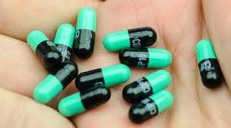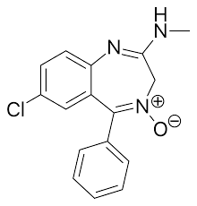

Chlordiazepoxide is the Trust’s treatment of choice for alcohol withdrawal. Referring to the Trust guidelines and other resources find out what it is, how and when it’s used. Also consider when and why we wouldn’t give it, what would we use instead?

16. Pabrinex
The preferred method of administration is IV but it can be given IM. It contains water-soluble vitamins: C, B1, B2, B3, and B6.
What is it used for?
- It rapidly corrects severe depletion or malabsorption of vitamins B and C. Especially where a severe depletion of thiamine can lead to Wernicke’s encephalopathy.
How does it work?

17. Refeeding syndrome
Describe what it is and why it would be so prevalent amongst our patient group, how is it identified and treated?

18. Alcohol Related Liver Disease (ARLD)
The symptoms of ARLD depend on the stage of the disease. There are three stages:
- Alcoholic fatty liver disease

- Acute alcoholic hepatitis:

- Alcoholic cirrhosis:

Some people with ARLD don’t have symptoms until the disease is advanced. Others start showing signs earlier. Symptoms of ARLD include:

Treating alcoholic liver disease
ARLD treatment has two goals. The first is to help patients stop drinking. This can prevent further liver damage and encourage healing. The second is to improve their liver health.
We might recommend:
- Alcoholic rehabilitation program/community support
- Multivitamins:

19. Wernicke-Korsakoff Syndrome
Wernicke-Korsakoff syndrome (WKS) is one name for two conditions that often happen together. Many think of them as different stages of the same disease.
They can happen if patients don’t get enough vitamin B1, also called thiamine. Vitamin B1 helps the brain turn sugar into energy. When the brain and nervous system don’t get the amount they need, they don’t work as well.
Wernicke encephalopathy typically comes on suddenly, and patient’s need treatment right away. Symptoms include confusion, loss of muscle coordination, and trouble with vision. Korsakoff syndrome happens more slowly. It’s a long-term, ongoing problem that damages the part of the brain that handles memory.
The 3 main symptoms of Wernicke’s Encephalopathy are:

Patients may have problems with their heart and blood vessels that can lead to:
- Drowsiness
- Fainting
- A faster heartbeat than normal
- Low blood pressure when you stand up
- A lack of energy
If they aren’t treated for Wernicke encephalopathy quickly, it can lead to Korsakoff syndrome.
Symptoms of Korsakoff syndrome usually begin as the signs of Wernicke encephalopathy start to go away. The telling sign is the loss of short-term memory. That also makes it hard for patients to learn anything new or make new memories.
Patients might talk to someone and seem like themselves. But a minute or two later, they won’t remember anything about it, not even who they’ve spoken with.
Patients may also have:
- Some long-term memory loss
- Confabulation
- Hallucinations
- A hard time putting words into context
- Trouble understanding or processing information
What causes Wernicke’s?

How is it treated?

What are the complications and prognosis of Wernicke-Korsakoff syndrome?

20. Hepatic Encephalopathy
Hepatic encephalopathy (HE) refers to changes in the brain that occur in patients with advanced, acute (sudden) or chronic (long-term) liver disease. It is one of the major complications of cirrhosis.
It can occur suddenly in people with acute liver failure but is more often seen in those with chronic liver disease.
How does Hepatic Encephalopathy (HE) develop?

What are the symptoms of HE?

How is HE treated?

21. Liver Function Tests
Liver function tests help determine the health of your liver, by measuring the level of proteins, liver enzymes and bilirubin in your blood.
They commonly include:
- Alanine Transaminase (ALT)
- Aspartate Aminotransferase (AST)
- Alkaline Phosphate (ALP)
- Albumin
- Bilirubin
- Gamma-glutamyl transferase (GGT)
Take some time to find out a little more about each, when would we use them, and what would be looking to see.

22. Stigma
Most will agree that alcoholism is a type of illness. Nobody chooses to develop this kind of problem. Drinking is very much part of the culture in most western countries, and the transition from social drinker to alcoholic can occur without the person even noticing; this can happen because of the power of denial.

The reason there is such a stigma associated with alcoholism is that it is viewed as an over-indulgence. A common stereotype is that alcoholics lack willpower, while wilfully engaging in bad behaviour.

It is common for those who begin to abuse alcohol to do so for a logical reason. These are often individuals who are struggling to deal with life, suffer from mental health problems or are victims of abuse.

These people can turn to alcohol as a type of self-medication, and the reason they continue to engage in the behaviour is that it can work in the beginning, making them feel better. The problem is that the person has to keep on drinking more and more to get the same level of relief; the more these people drink, the worse their life becomes. By the time the individual is able to see the cons of drinking outweigh the pros, they are already addicted.

What is the common stereotype of someone alcohol dependent?

What might be some reasons people fear the stigma of alcoholism?

23. Talking to patients
Bias
We are all naturally biased and have preferences towards some people/groups. Biases only become a problem when we act out our biases.

Unconscious bias
Unconscious biases, also known as implicit biases, are the underlying attitudes and stereotypes that people unconsciously attribute to another person or group of people that affect how they understand and engage with a person or group.

- What impact might unconscious bias have on patients that HALS see?

- How do we be more aware of our hidden preferences, attitudes and stereotypes?

- How do we be more intentional in our actions, more inclusive and compassionate?

24. Health Promotion
What do you understand about the term Health Promotion?

Whose responsibility is health promotion?

The RCN believe improving public health should be seen as part of all nursing roles. Health promotion activities are geared toward promoting health and preventing ill-health rather than focusing on people at risk for specific diseases. Health promotion: Enables people to increase control over and improve their health. It involves the population as a whole in the context of their everyday lives.

Health Promotion and Alcohol
Nurses can significantly impact an individual patient but it is essential to understanding the principles of supporting behaviour change.
- Provide alcohol screening (using validated tools) and brief, structured advice to individuals drinking above lower-risk levels using training resources and e-learning courses.
- Ensure alcohol screening and brief advice is delivered effectively in line with national guidelines.
- Direct individuals drinking above lower-risk levels to appropriate support materials and alcohol learning resources.
- Refer those with alcohol dependence to specialist services
- Provide holistic health assessments

25. Dual Diagnosis
Dual diagnosis treatment is the term most often used to describe how those who have both a mental illness and addiction are treated.
Co-occurring disorders describe a variety of diseases that commonly occur along with drug abuse or alcohol addiction.
In co-occurring disorders, both the mental health issue and alcohol addiction have their own unique symptoms that may get in the way of their ability to function at work, maintain a stable home life, handle life’s difficulties, and relate to others.

How might co-occurring disorders affect each other?

What might be the best treatment approach for co-occurring disorders?

26. The Toxic Trio of Safeguarding
The term toxic trio has been used to describe the issues of domestic abuse, mental ill-health and substance misuse.
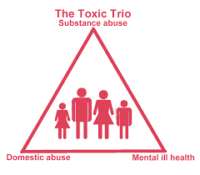
Why is it important to be aware of the toxic trio?

Who should address the toxic trio?

What is common about the way these issues impact families?

What makes these issues hard to tackle?

Conversation starters

Mental Health Difficulties
- You seem upset/low/under the weather. How are you feeling now?
- Have you ever had contact with your GP or other mental health services about how you’re feeling?
- Do you think this affects the way you care for your child/ren?
- Can we talk a bit more about this to see how we can best support you?

Substance misuse
- Sometimes people cope with difficulties by drinking or taking stuff. Have you or anyone else ever been worried about this?
- Have you ever had support?
- Do you think this affects the way you care for your child/ren?
- Can we talk a bit more about this to see how we can best support you?

Domestic Abuse
- How are things at home? Are you afraid or worried about your relationship?
- Have you ever had support about this?
- Do you think this affects the way you care for your child/ren?
- Can we talk a bit more about this to see how we can best support you?

Remember:
- Early intervention is essential
- Understand the risk is dynamic and fluid, people can be chaotic
- Relevant and proportionate information sharing: justifiable
- Professional curiosity

27. Safeguarding
Who might HALS have safeguarding concerns about?

The Care Act (2014) identifies 10 categories of abuse. Can you list them and give a brief description:

What action would you take if you had safeguarding issues and can you support this with Trust guidance/policy?

28. Communication
Due to the complex nature of these patients, communication failures can lead to missed therapeutic opportunities. It is therefore essential to acknowledge and assess factors that generate tension between the patient and the healthcare professional. Have a think about the following:

- Verbal communication barriers:

- Non- verbal communication barriers:

- Healthcare professional attitudes:

- Patient anxiety:

- Irritable patients:

How can these be overcome, how can you tailor your communication?

29. Holistic care
What are the 5 aspects to holistic care and what do they include?

Why is holistic care of importance?

30. What are brief interventions?
A brief intervention is a short, evidence-based, structured conversation about alcohol consumption. It seeks to motivate and support the individual to consider a change in their drinking behaviour in order to reduce their risk of harm. There are a number of tools designed to help practitioners determine a patient’s level of risk to alcohol harm.
Several research studies show that brief interventions are effective and can reduce alcohol consumption among people who are drinking at hazardous or harmful levels, but who are not dependent on alcohol.
For people who are alcohol dependent, referral to specialist alcohol services is the only intervention which is proven to help.
Despite strong evidence and opportunities for brief interventions, they seldom occur.
Brief interventions take a supportive, non-confrontational approach, which empower the patient to recognise the risks associated with their drinking patterns, the benefits of reducing intake, and motivate them to adjust their lifestyle. The aim is to make it a natural part of any consultation. It is worth reinforcing your message by handing the patient written advice to take-away and read.

Open ended questions
By using open ended questions you are the patient the opportunity to answer whatever they like, without limiting or influencing them with predefined answers.
Give some ideas of how you may ask about
- Asking permission to discuss their alcohol consumption

- Normalising their drinking pattern

- Identifying patient’s level of motivation

- Exploring patient health beliefs

31. FRAMES
Brief intervention for alcohol use can take place within the context of a typical consultation session following assessment or screening. Effective brief interventions need be no longer than 5-15 minutes in duration. The format for an effective brief intervention typically involves certain elements which are conveyed by the FRAMES model.
- Feedback
- Responsibility
- Advice
- Menu of Options
- Empathy
- Self-efficacy

FRAMES model for health risk behavior counseling | Download Scientific Diagram (researchgate.net)

Using the link above reading around how the FRAMES model can be used by HALS.

32. Stages of Change (Prochaska & Diclemente 1983)
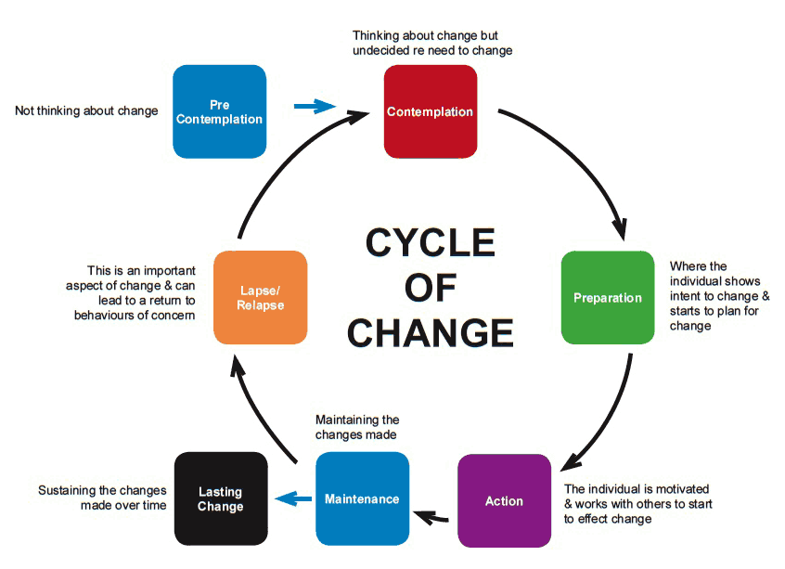

The cycle of change can be used to identify where patients are with making changes. Do some further reading on the cycle and see if you can identify each stage below?

___________________: in this stage, the individual who is drinking at increasing or higher risk levels is not considering change in the near future and may not be aware of the actual or potential health consequences related to drinking at these levels.

___________________: this stage occurs when the changes are not reinforced and the individual regresses to an earlier stage.

___________________: in this stage, the individual will now be drinking at lower risk levels or may even be abstinent on a relatively permanent basis.

___________________: in this stage, the individual will have begun to cut down or stop drinking but this will not yet have become a permanent change.

___________________: in this stage, the individual may now be aware of alcohol-related health consequences but is ambivalent about changing.

__________________: in this stage, the individual will have already decided to change and plans to take action

33. Kubler Ross Grief Cycle (1969)

Originally applied to people suffering from terminal illness, it was later applied to any form of catastrophic personal loss (job, income, freedom). This can include significant life events like death of a loved one, divorce, drug addiction, disease/chronic illness, infertility as well as many tragedies and disasters.

The five stages do not come in a specific order and not all are experienced by patients but most experience at least two. Some may experience several stages in a ‘roller coaster’ effect, switching between two or more, returning to one or more several times before working through it.

The grief process should not be forced; it is highly personal and should not be rushed, nor lengthened. The patient should just be aware that the stages are worked through and the ultimate stage of ‘acceptance’ will be reached.

Tell us more about each of the stages of the cycle:

- Denial

- Anger

- Bargaining

- Depression

- Acceptance

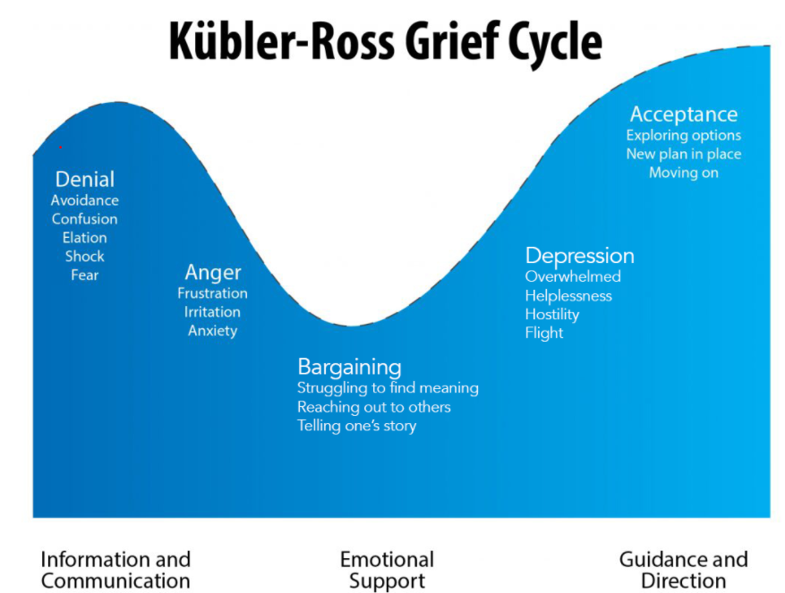

References
UK Chief Medical Officers' Low Risk Drinking Guidelines (publishing.service.gov.uk)
Guidance on the 5 alcohol use screening tests - GOV.UK (www.gov.uk)
Public health influence | Public Health | Royal College of Nursing (rcn.org.uk)
HIN_AIBA_Toolkit_v15-FINAL.pdf (healthinnovationnetwork.com)
Alcohol (greenfacts.org)
NHS Long Term Plan
Alcohol harms. Time for change. | Alcohol Change UK
Drinkaware Home | Drinkaware
Safeguarding and promoting the welfare of children affected by parental alcohol and drug use: a guide for local authorities - GOV.UK (www.gov.uk)
1 Guidance | Alcohol-use disorders: diagnosis, assessment and management of harmful drinking (high-risk drinking) and alcohol dependence | Guidance | NICE
CG100 Full guideline (nice.org.uk)
(https://www.gov.uk/government/publications/alcohol-use-screening-tests)
British Liver Trust - Pioneering Liver Health
FRAMES model for health risk behavior counseling | Download Scientific Diagram (researchgate.net)

