- Introduction

Learning Environment

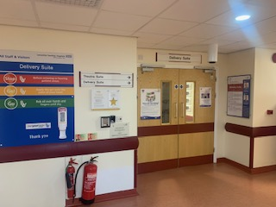
Delivery Suite

Learner Booklet

Welcome
We would like to warmly welcome you to Lancashire Teaching Hospitals NHS Foundation Trust (LTHTR). Incorporated on the 1st of April 2005, LTHTR was the first trust in the county to be awarded “Teaching Hospitals” status.
We have created this pack as a useful resource to help you to settle in with us. The purpose of this booklet is to provide you with information to help you on your learning environment.

About LTHTR
We have three equally important strategic aims:
- To provide outstanding and sustainable healthcare to our local communities
- To offer a range of high-quality specialist services to patients in Lancashire and South Cumbria
- To drive health innovation through world class education, training and research
We provide a range of Hospital based health services for adults and children and cover a range of specialities. These include cancer services such as radiotherapy, drug therapies and surgery, disablement services such as artificial limbs and wheelchair provision. Other specialities include vascular, major trauma, renal, neurosurgery and neurology including brain surgery and nervous system diseases.
Our five core values:
- Being caring and compassionate
- Recognising individuality
- Seeking to involve
- Building team spirit
- Taking personal responsibility

We deliver care and treatment from three main facilities:
- Royal Preston Hospital
- Chorley and South Ribble Hospital
- Specialist Mobility and Rehabilitation Centre, Preston
In relation to car parking, please refer to your Induction to the Trust, for information regarding car parking. Additional information can be found on our Intranet page.
https://legacy-intranet.lthtr.nhs.uk/car-parking-documents

Learning Environment

We would like to welcome you to your learning environment.

Orientation to the ward
Delivery suite is located within the Sharoe Green Unit, second floor, Royal Preston Hospital.
We provide care and service to women and families who receive Consultant led care antenatally, labour and birth within our unit. Some may choose to give birth on the Delivery Suite because this is where they feel most comfortable, or due to the pain relief options available, giving women the choice of birth. We have one permanent pool and 3 inflatable pools.
We have approximately 250 to 300 births per month in our 12 ensuite birth rooms. We provide care for preterm women, intrauterine transfers from other Trusts and women who may be receiving treatment and care in other areas of the hospital i.e., neurology ward or critical care. We care for high-risk women who may require high dependency care, manage emergency situations, and provide bereavement support to families and women.
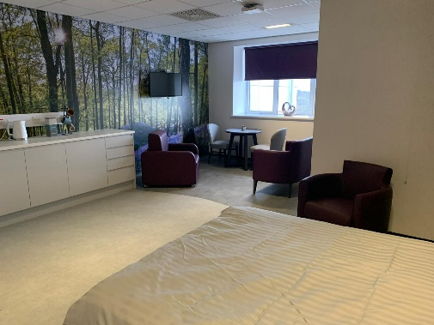
At the end of the corridor, we have direct access to the obstetrics and gynaecology theatres. Theatre one is a dedicated theatre for emergencies and theatre two is where elective caesarean cases take place.

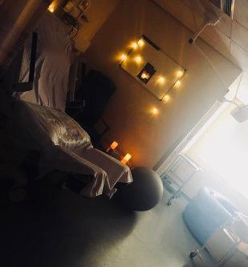

Sickness policy
Please contact the ward area and speak to the delivery suite coordinator by telephone 01772524731 in a timely manner to notify the area of your absence from shift. Please email your academic assessor, practice assessor and the learner absences team with the details of your absence and update your PARE timesheet accordingly.

Changing facilities specific to this learning environment

Women changing facilities within the Sharoe Green Unit. Located on the second floor on the delivery suite, opposite the staff room. You will need the access code, please ask a member of staff on arrival to delivery suite. There are lockers located in the changing room and emptied at the end of your shift.

Team structure, including wider Multidisciplinary Team

Our maternity team includes Obstetricians, Midwives, Maternity Support Workers, Clerical Staff, Student Midwives and Medical Students all of whom endeavour to work together to create a positive experience for all women and families who choose to birth with us.

On a shift we have a delivery suite coordinator who leads, manages and has oversight of the activity on delivery suite area. We have a second band seven who supports the coordinator and midwives on duty. We have a further 4 midwives on duty, this includes one core delivery suite midwife, band 6 and band 5 rotational midwives.
We have our housekeeper Mandy Holt and we have a maternity support worker on each shift to help provide a range of personalised care for women and support the productive operation of the delivery suite environment by undertaking a range of non-clinical duties which contribute to the maintenance of a safe and clean environment.
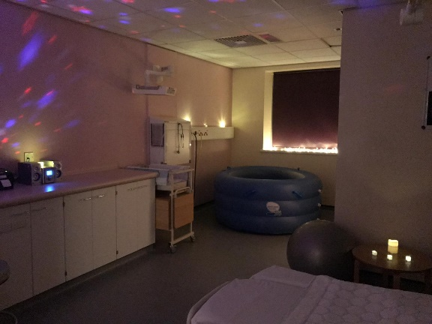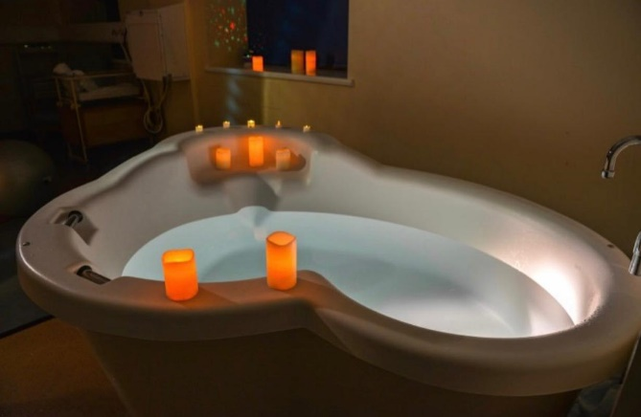

Hours of work

- 0730-2030 pm long shift (12.5 hours)
- 2000-0800am Night shift (11.5 hours)
Short shifts if requested as follows:
- 0730-1530pm (30-minute break)
- 1230-2030pm (30-minute break)

Contact telephone numbers

01772524731 Delivery Suite Station
01772524219 Delivery Leads Office Hannah Mercer

Learning opportunities available

- Looking after women through the antenatal, labour and birth period
- Preterm birth
- Multiple birth
- High risk care
- Inductions of labour
- IV Cannulation, venepuncture and Iv drug administration
- Assisting with siting epidurals and ongoing care of women with epidurals
- High dependency care i.e., PPH, Pre-eclampsia
- Immediate postnatal and neonatal care including newborn check, breastfeeding support, skin to skin etc.
- Going to theatre - i.e., caesarean sections, repair of tears, instrumental deliveries
- Remifentanyl
- CTG Interpretation
- Episiotomies
- Waterbirth
- Vaginal Examination's / Artificial Rupture of Membranes's / Fetal Scalp Electrode's
- Fetal blood sampling
- Suturing
- Documenting all actions on Badgernet -our paperless system.
- Working with all members of the multidisciplinary team.
- Assisting with the running of the ward, i.e., cleaning rooms, refreshments etc.
- SBAR handovers

List of commonly used medications

- Paracetamol
- Ibuprofen
- Dihydrocodeine
- Cefalexin
- Ferrous Sulphate
- Lactulose
- Fragmin
- Chlorpheniramine
- Benzylpenicillin
- Pethidine

Transferable skills

- Communication
- Medicine management
- Observations
- Post-op care
- Wound care
- Multidisciplinary team working
- Documentation/
- Escalation
- Feeding
- Hydration
- Risk assessments
- Catheter care
- Pain management

Sources of Help and advice

Should you encounter any problems during your time on placement you can access support from:
- Your mentor
- Freedom to speak up champion.
- Ward manager Hannah Mercer
- Student clinical link Midwife
- Any midwife or staff member you have confidence in#
- Escalate to placement support/ University.
- Practice supervisors and assessors
- Human Resources
- Occupational Health
- Pastoral Care
- Staff Wellbeing Board located on delivery suite and information on the intranet.

Catering facilities
- 1 hour break (Can take 2x30 minute breaks).
- Fridge-must label food with name and date.
- Staff fridge located in the staff room
- Kitchen facilities located in the staff room-microwave, hot water, tea and coffee facilities.
- Charters Restaurant. Hot/cold food available in the canteen. M&S/WHSmith/Costa shop available at the main entrance.

What to bring on your first day
- Uniform
- ID badge
- Fob watch (useful to have)
- Lunch
- Drinks bottle – its very important to keep hydrated on shift, we have a water machine in the unit for both staff and patient use. There is also hot drinks facilities and milk you may use in the staff kitchen.
- Note pad and pen – you may find it useful to keep note of any important information/guidance to aid your learning journey throughout your time on placement.

Expectations and Professional Values

Please familiarise yourself with the trusts uniform policy and infection control – these can be found on the intranet under ‘policies and guidelines’. https://legacy-intranet.lthtr.nhs.uk/search?term=uniform+policy We remind you that:
- Hand hygiene is essential
- Only simple studs should be worn if you wish to wear earrings
- No wrist watches/bracelets or necklaces to be worn
- No false nails/nail varnish
- Remember ‘bare below the elbow’- when entering a clinical space you should be bare below the elbow and jackets should not be worn unless outside of a clinical area and adheres to trust policy.
Regular audits are conducted within all departments to ensure professional standards are met and monitored. Whilst on clinical placement please remember your responsibilities in accordance with the NMC guidance on professional conduct for nursing and midwifery students.

Our values and our culture at LTHTR:

- Compassionate
- Respectful
- Empowered
- Collaborative
- Performance focused

We look forward to welcoming you to our Delivery Suite and sharing our knowledge to the future workforce of maternity. Please feel free to ask lots of questions and we hope you enjoy your time working with us!

Induction

The Local Induction process will take place throughout the first week of your placement.

This will comprise of:

- Trust and department orientation, including housekeeping information.
- Location of emergency equipment
- IT access
- Reading & acknowledgement of Mandatory Trust policies such as Health & Safety, Fire Safety, Infection Control, Information Governance, Staff Code of Conduct, Social Networking and Dress Code policies.
- Adult Basic Life Support training if applicable
- Trust Moving & Handling Training if applicable.
- COVID-related policies & procedure

Follow trust guidelines.

- Orientation
- Professional voice: - freedom to speak up, datix, chain of command, open door policy.
- An awareness of our Educational Governance Team- evaluation and importance of feedback
- Inter-professional Learning Sessions
- Practice Assessment Record and Evaluation (PARE) training, if applicable
- Collaborative Learning in Practice (CLiP™), if applicable
- How the role of Practice Development Facilitator can support you, where applicable

What to bring on your first day

- Uniform: All other items in the dress code policy must be adhered to https://legacy-intranet.lthtr.nhs.uk/search?term=uniform+policy
- A smallish bag which would fit into a small locker.
- You may wish to bring a packed lunch and a drink on your first day.

Inter-professional Learning Sessions and eLearning Resources

At our Trust, our Education Team facilitates a yearly programme of Inter-professional Learning (IPL) sessions. This programme consists of various teaching sessions, delivered by our Specialist Teams, to support and enhance our learners and trainees’ learning experience with us.
Inter-professional learning is an important part of your development and allows you to build professional relationships and communication skills with the wider multi-disciplinary teams. Our IPL sessions are valuable in supporting you to stretch your knowledge and experiences to enhance your clinical practice. They also help bridge the gap between theory and practice, allowing you to hold a deeper understanding of the topics discussed. Our sessions are open for all learners and trainees on placement at our Trust to attend and these learning opportunities are an extension to your learning environment; therefore, these hours need to be recorded on your timesheets. We encourage our staff to facilitate enabling a learner/trainee to attend these sessions.
Please note: You must inform your learning environment prior to attending a session. These IPL sessions need to be discussed in a timely manner with your learning environment.
You are required to complete a reflection on each of your IPL sessions, as well as documenting on your HEI documentation what you have learnt and how this relates to your current placement.
You can book onto our IPL Sessions by accessing this link https://elearning.lthtr.nhs.uk/login/index.php and searching for ‘IPL’.
You can access our policies and procedures via our Intranet page, which will help expand and stretch your knowledge.

Support with evidencing your learning outcomes or proficiencies.

We encourage you to use your reflective journal entry on PARE to collate and evidence your skills, knowledge and abilities achieved. You can then present your completed reflections to your Practice Assessor/Educator during your assessment meetings. Any staff member who is involved in coaching you can complete your practice supervisor feedback.

You can request time during your placement hours to complete these and request feedback prior to the shift ending.

Chain of Command
Keeping patients safe, providing the best care that we can and learning in an environment where you feel safe and valued is important to us. Speaking up about any concern you have on your learning environment is also important. In fact, it’s vital because it will help us to keep improving our services for all patients.
There may be occasions where we witness, experience or are asked to do something that causes us concern. Often, these concerns can be easily resolved, but sometimes it can be difficult to know what to do.
Our Clinical Placement Support Team are available Monday – Friday, 8.00am – 4.00pm should you need to contact them in relation to any concerns regarding your learning environment. If your concern relates to patient safety and/or your concerns are outside of these hours, please follow the chain of command in your learning environment and speak with the person in charge.

Please visit our Freedom to Speak Up page on the Intranet for more details.

We value your feedback.

Our Trust values your feedback. To continuously improve, we offer opportunities for our learners and trainees to provide feedback regarding both your learner experience and your learning environment. We would encourage you to kindly complete your end of placement evaluation, within your clinical hours.
We will keep you updated with the improvements that we make based on the feedback you provide us with.

Learning Environment Improvement Forum

Our Learning Environment Improvement Forum began in November 2021, with key stakeholders attending; Learners, Trainees, Clinical Staff, Education Leads and our Nursing Directorate. Monthly meetings are held to share new and innovative ideas as to how we can collaboratively enhance our learning environments, to support both learners, trainees and staff.
All attendees at the Learning Environment Improvement Forums contribute their suggestions and guidance on our projects. Collaboratively, exciting improvements are implemented to enhance our learning environments.
Innovative changes made by our Learning Environment Improvement Forum, within Academic Year 2021-2022.
- NEW Learner Boards designed and placed on our learning environments.
- Learner booklets made available on our Health Academy webpage to prepare our learners and trainees for their clinical placements, as suggested by our learners and trainees.
- PARE and CLiP™ training embedded into our Learner and Trainee Inductions
- Quick Reference Guide designed and created to welcome our learners and trainees to the Trust and prepare them for their clinical placements.
We welcome any of our staff, learners and trainees at the Trust to attend our Learner Environment Improvement Forums, to contribute your ideas and suggestions for our new and innovative projects. You can join via the E-Learning Portal - https://elearning.lthtr.nhs.uk and going to Courses, then selecting the tab ‘Inter Professional Learning’, where you will see our forum listed.

